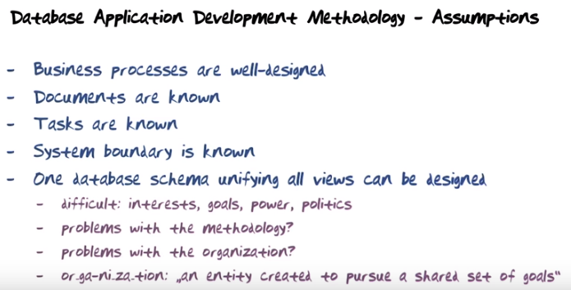
上圖中的問題: If it is that difficult, is it a problem with a methodology or is it a problem with the organization? It is always a problem with the organization. …. If your organization cannot successfully arrive at such a unifying view, then it's a problem with the organization.

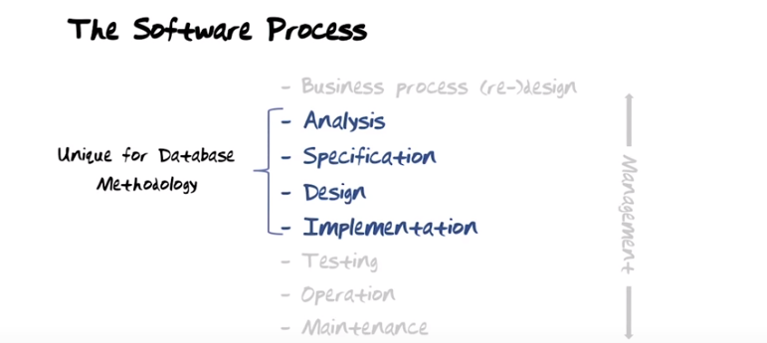

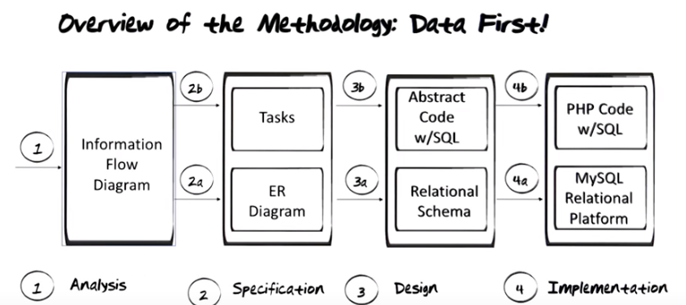
上圖: In database application development methodologies, data is always first. In general software development methodologies, process is often first. So they will concentrate on laying out the class diagrams in just the right way to get the functionality just the the right way and then they will hang the data on the declares where they fit. In database development its data first and oce the data is desingned just right, we will hang the processes on where they fit.
上圖中最左邊的輸入是information provided by the customer (the customer's requirment). 上圖的意思就是: 在Software Process的Analysis階段, databas任務對應的就是Information Flow Diagram, 其餘的類似.
注意本節課(及本note)之題目即為Methodology I: ANALYSIS. 所以是focus on analysis的.
以下是6400 Syllabus中的圖, 就是按上圖來的. 而analysis, specification, design, implemetation這四個最初來自哪裡? 自上上圖就知道了, 它們就是software process中的幾步啊.

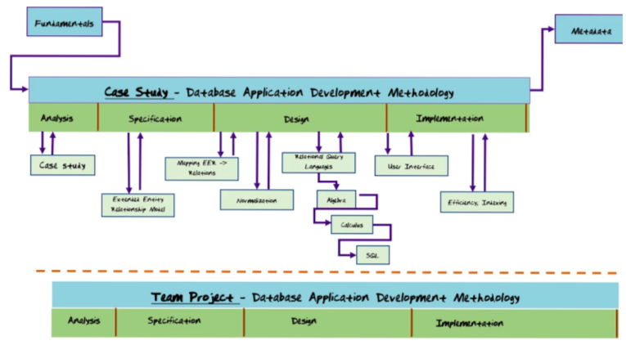

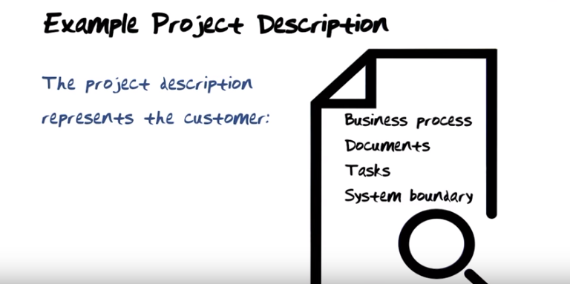
The above figure: I'm gonna go through a project description that represents the customer. If you don't read that description, you won't be able to get anything out of the rest of this course.

As an example, we're going to use GTA online.



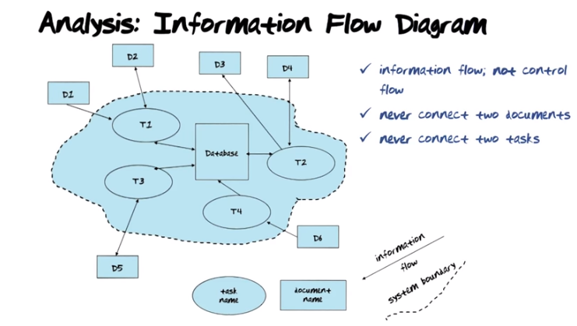
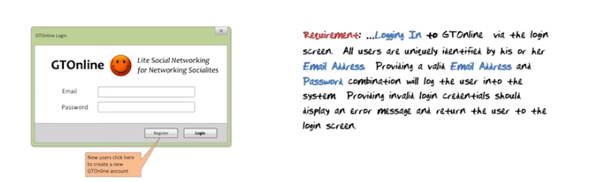
The above figure: Notice as the user interacts with the login screen, the information provided is not written into the database as a result of the login process. However, the task that checks the login information will read information from the databse to make sure that the user shows &%#@# to login is a valid user and provide the correct email and passoword. So this is purely an input document.

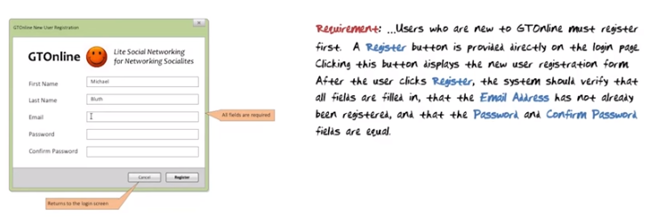
The above figure: Notice that the register document is an input document to the system, and as result of interacting with that registration task, the information will be written into the database.

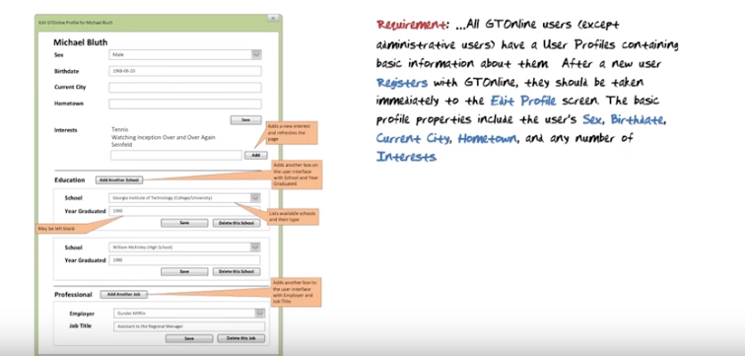
The above figure: The Edit Profile screen obviously is going to result in potentially many types of information being written into the database: the personal information, interests, education information, and professional information. But notice that there will also be information that read from the database. For example, because the drop down list for school and the drop down list for employer needs to be controlled in the database to populate the screen.

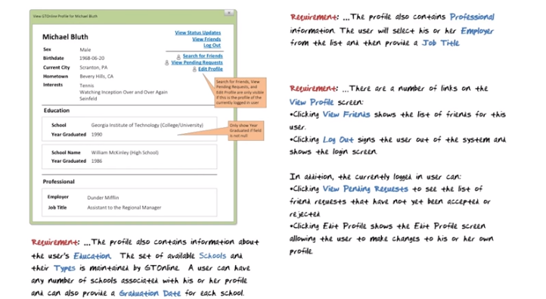
The above figure: Notice that the view profile screen is not an input to the database. It is an output document from the database, where all the information about the user's profile has been read from the database and written on to this output document. Threre's of course control information here (左上角的那堆藍字) that leads you to a different screen depending on which link you choose.

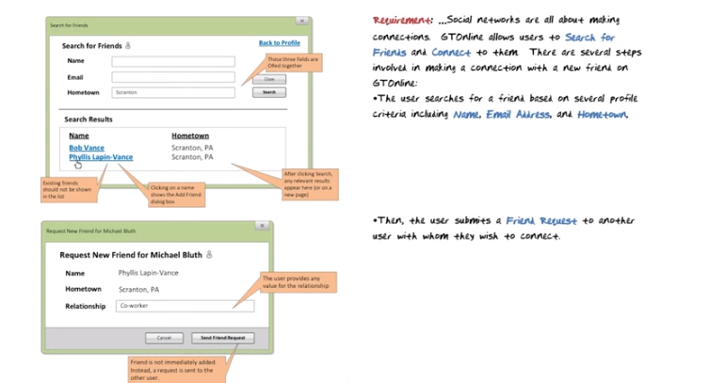

The above figure: The search screen is an output document. The request new friend screen is an input document to the system.

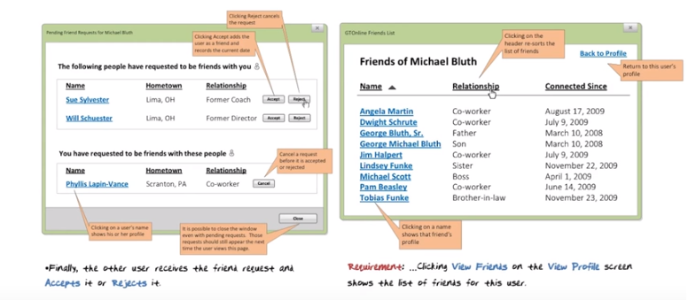
The above figure: The pending friend request screen is both an input and output document. It's an output document from the database because it displays information from the database. It's also an input document to the database because it will cause changes in the database depending on whether you hit the accept or reject button. Of course if you hit the cancel button, it will delete your request to Phyllis for her to become a friend of yours. The friends list form is an output document from the database.

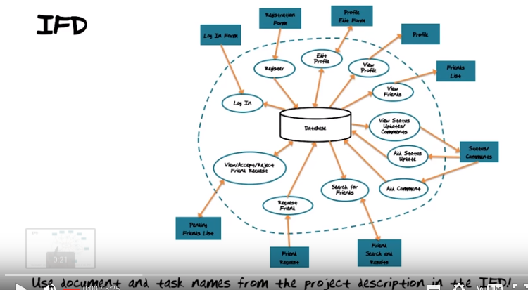
上圖中的IFD即Information Flow Diagram, 見前面的圖(已截圖到下面). The output of the analysis phase of the database application development methodology is an information flow diagram.

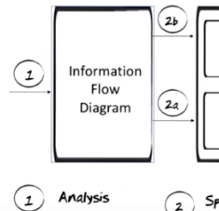

上圖是截的前面的圖, just for convenience to view.

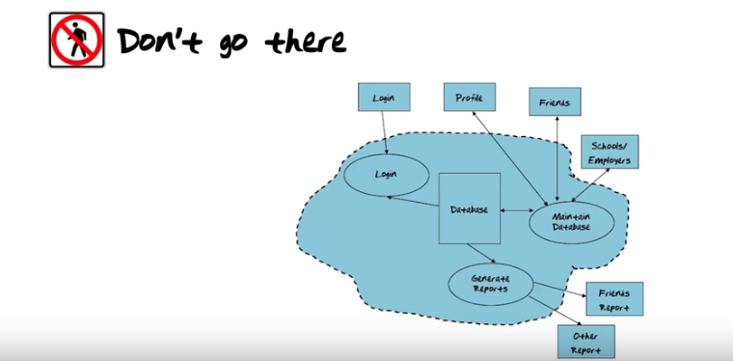
The above figure: Don't do that. That does not model the future system you are building. 沒做太多解釋.

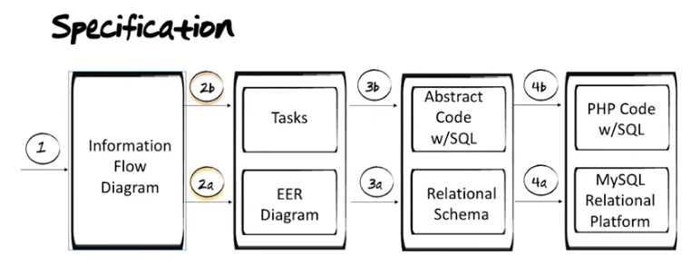
上圖的意思就是說下一步是specification.

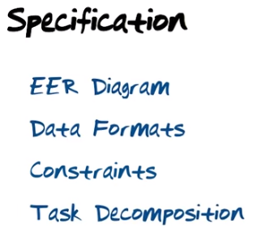

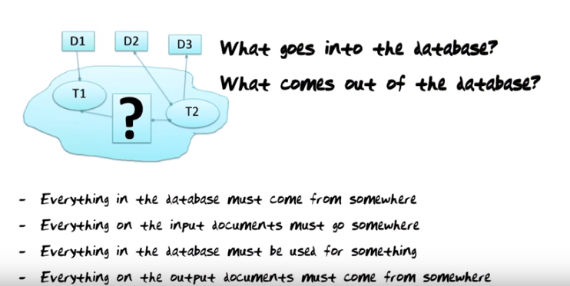


上圖: Before we go any further, we need a small detour to study an additional database tool or technique.

